Q1. Find out about the Java API (<https://docs.oracle.com/javase/7/docs/api/>). what does the above API's do?

**java.io**: Java.io package provides classes for system input and output through data streams, serialization and the file system. It is a Java IO API located in java.io package. It is used to process the input and produces the output based on the input. This package contains all the classes required for input and output operations. We perform file handling in java by java.io API.  
Example: System.out, System.in

**java.util:** Contains the collections framework, legacy collection classes, event model, date and time facilities, internationalization, and miscellaneous utility classes (a string tokenizer, a random-number generator, and a bit array). The package java.util contains a number of useful classes and interfaces.   
Example: interface Enumeration, BitSet, Date etc.

**java.sql:** Provides the API for accessing and processing data stored in a data source (usually a relational database) using the Java programming language. The java.sql package contains the entire JDBC API that sends SQL (Structured Query Language) statements to relational databases and retrieves the results of executing those SQL statements.

**java.lang:** Provides classes that are fundamental to the design of the Java programming language. The most important classes are Object, which is the root of the class hierarchy, and Class, instances of which represent classes at run time. A value of primitive type represent as if it is an object. The wrapper classes Boolean, Character, Integer, Long, Float, and Double serve this purpose. An object of type Double, for example, contains a field whose type is double, representing that value in such a way that a reference to it can be stored in a variable of reference type.

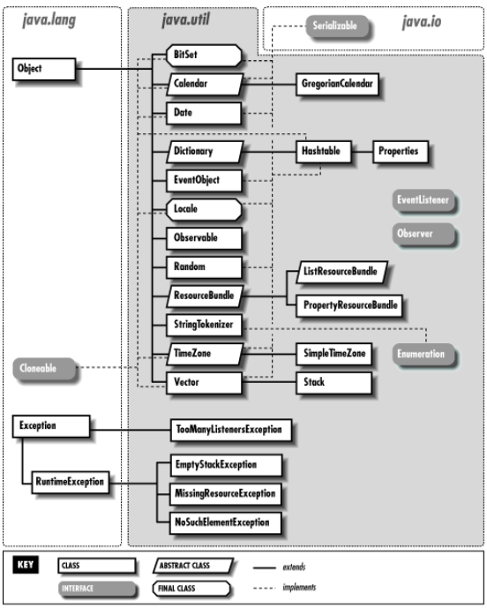

Q2. Ask user to provide the following values

1. Start
2. Import java.util.Scanner (Scanner class allows to accept keyboard input)
3. Define principal P
4. Define rate R
5. Define time T
6. Calculate simple interest = (P*R*T)/100
7. Calculate Amount = principal + simple interest
8. Print the simple interest
9. End

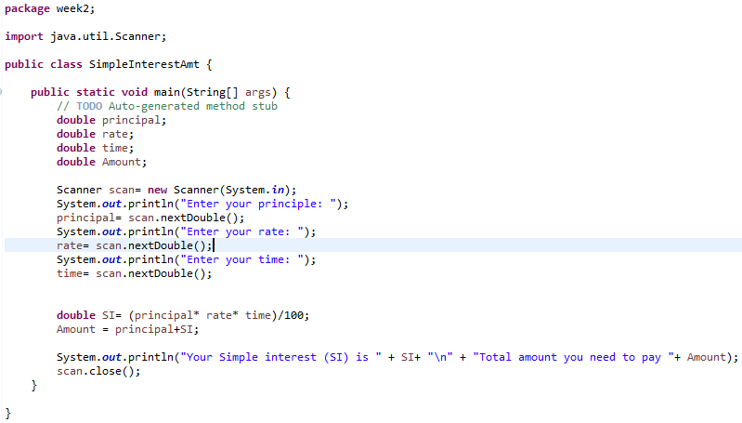

Q3. Explain the nextInt(), next(), nextDouble(), nextBoolean() methods of the scanner class.

nextInt()- Retrieves input as an integer

next()- Retrieves the next complete token as a String

nextDouble()- Retrieves input as a double

nextBoolean()- Retrieves input as a boolean